Default logoff page of FLP is like below..

[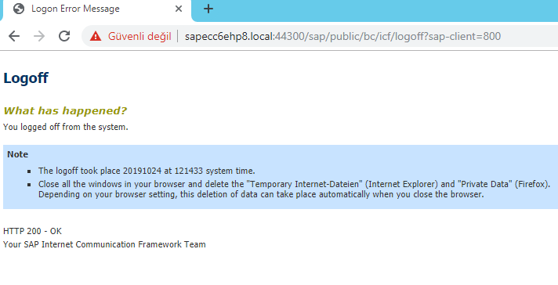](http://zyndanismanlik.com/wp-content/uploads/2019/10/1-3.png)

In order to redirect the user to logon screen when the user signs out, go to service /sap/public/bc/icf/logoff via SICF and change the redirect URL as /sap/bc/ui5_ui5/ui2/ushell/shells/abap/Fiorilaunchpad.html

[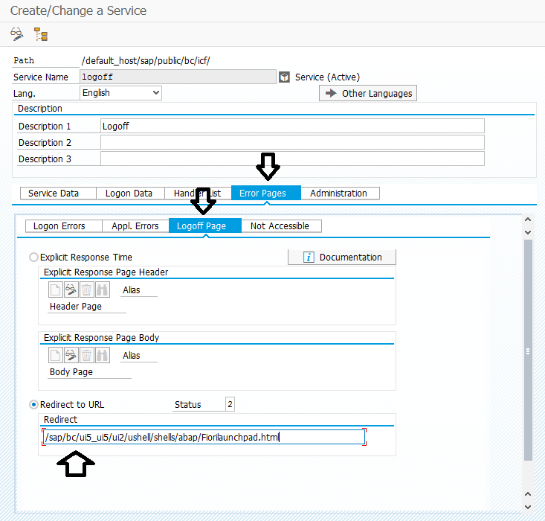](http://zyndanismanlik.com/wp-content/uploads/2019/10/2-2.png)